

TURNTABLE Hi-Fi SYSTEM

MODEL: TT30AT

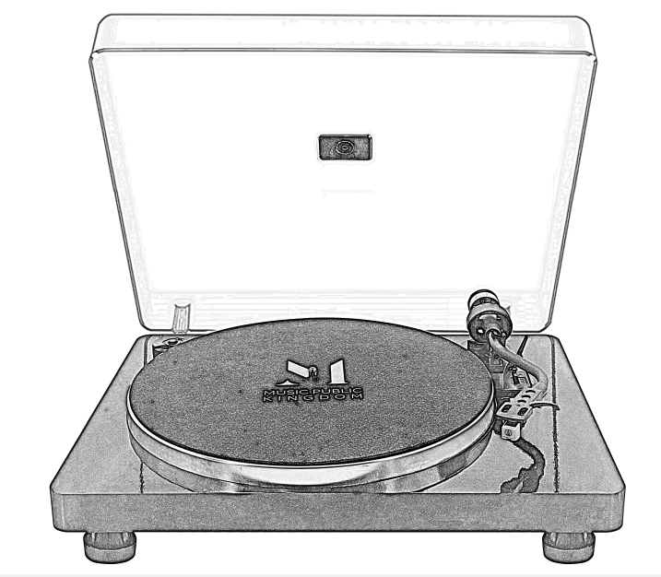

**Instruction Manual**

PLEASE READ THIS MANUAL CAREFULLY BEFORE USE AND KEEP IT FOR FUTURE REFERENCE

**BEFORE USE**

1. Choose a safe location and avoid placing the unit in direct sunlight or near any heat

source.

2. Avoid environments subject to vibration, excessive dust, cold or moisture.

3. Due to the risk of electrical shock, do not open the cabinet. Should a foreign object

accidentally find its way into the interior of the unit, contact your local dealer.

4. Do not attempt to clean the unit with chemical solvents as this might damage the

finishing. A clean, dry cloth is recommended for cleaning.

1. Keep this manual for future reference.

**TURNTABLE PARTS:**

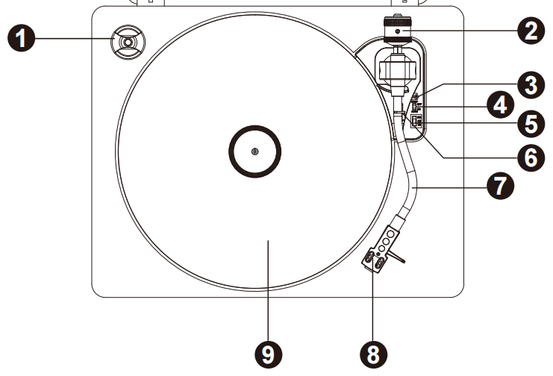

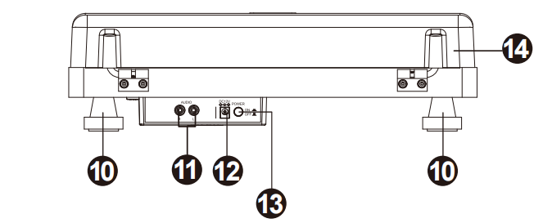

1. 45RPM Adaptor
2. Tonearm Counterweight—adjust the counterweight to make sure that the needle pressure is at 3G, +-0.5G measured by a needle balance(not included
3. Lift Lever
4. Auto stop control switch
5. 33/45/78 RPM Speed Switch
6. Tonearm lock
7. Tonearm
8. Stylus/Needle Cartridge—Audio Technica AT-3600L MM cartridge
9. Platter
10. Phono foot
11. L/R RCA Output Jack—to connect other external amplifier or speaker system with RCA audio cable(not included in the package)
12. DC IN Power Jack—to connect power adaptor for power
13. Powe ON/OFF Button
14. Dust Cover

**Getting Started**

Fix the dust cover onto the main unit via the two hinges.

Use the RCA audio cable to connect the turntable player with external speaker system(with power amplifier built-in) via the RCA output jack at rear of the unit.

Firmly and securely insert the DC plug of the adaptor to the DC IN Jack on the back of the unit.

Plug the adaptor’s AC plugs into a power outlet.

Press the power ON/OFF Button to ON.

**Phono Mode**

1. Raise the dust cover
2. Place a record on the turntable platter and select the desired speed (33/45/78 RPM) according to the record. **NOTE:** when playing a 45RPM record, use the 45RPM adapter
3. Remove the stylus protector. Open the tone-arm clip to release the tone-arm. Push the lift lever backward to raise the tone-arm and gently move the tone-arm to the desired position over the record. The turntable will begin to spin when the arm is moved toward the record. Push the lift lever forward to lower the tone-arm slowly onto the desired position on the record to begin playing the record.

If the Auto Stop Control Switch is turned ON, the record will stop automatically when finished. If Auto Stop Control Switch is turned OFF, the record will NOT stop automatically when finished; you must push the lift lever backward to raise the tone arm and place it back in the rest and then turn off the power to stop the turntable from spinning.

Remark: AUTO STOP function applies to most 33RPM vinyl records. However, for very few vinyl records, it will stop when it does not come to the end, or it will not stop when it comes to the end when AUTO STOP is ON.

When it stops before going to the end of record, switch the AUTO STOP to OFF, then the playback will continue.

**Drive Belt Assembly**

The belt and turntable platter have been installed properly at factory, but the belt may be

loose during transportation. If so, the following procedures will be taken for belt installation

by yourself:

A. Remove the felt mat from the turntable platter and the E ring from the turntable shaft,

then release the turntable platter from the shaft.

B. Put the drive belt on the inner rim of the turntable platter and put back the platter through the shaft.

C. Hold the belt with your fingers and place the belt onto the motor pulley as shown in below

drawing.

D. Clip the E ring on the shaft and place the felt mat onto the turntable platter.

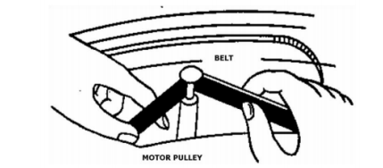

**Caution**

1. Make sure that the drive belt is not twisted or distorted.

2. Avoid oil. Oil splashes will make the belt slippery

**TIPS FOR BETTER TURNTABLE PERFORMANCE**

1. When opening or closing the turntable cover, handle it gently
2. Do not touch the needle tip with your fingers; avoid bumping the needle against the turntable platter or record edge.
3. Gently wipe the dust cover and turntable housing with a soft cloth. Use only a small amount of mild detergent to clean the turntable and dust cover.
4. Never apply harsh chemicals or solvents to any part of the turntable system.

